**The Scythe:**

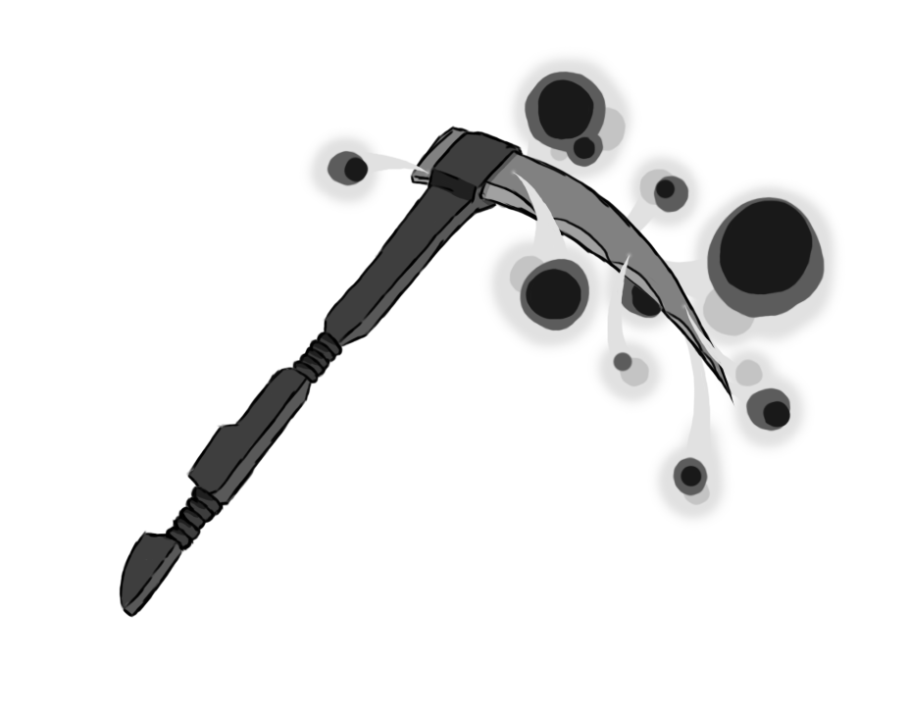

Figure 1 - Weapon: Scythe

**Brief Synopsis**

The scythe is an area of effect-based weapon used by the player. The main draw this weapon is its large hitboxes and ability, **life-steal** on kill. This can be used in tandem with weak enemies to recover health without much danger. The weapon however does have its drawbacks, with each swing the player commits to the attack, having large amounts of ending lag leaving the player vulnerable.

**Special Ability**

**Zipline:  
 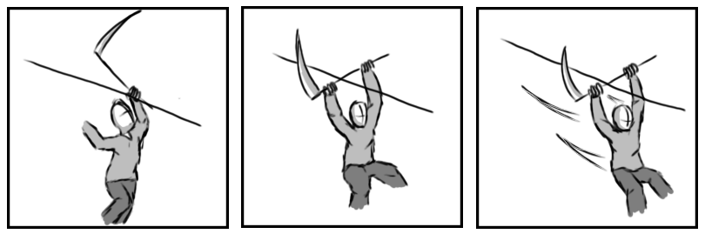**

Figure 2 - Animation Storyboard: Zipline

**Special:** Upon unlocking this weapon, the player will be able to latch onto the any zipline and slide down it. Hooking the scythes blade around the wire.

**Combat Ability’s**

**Jab:  
 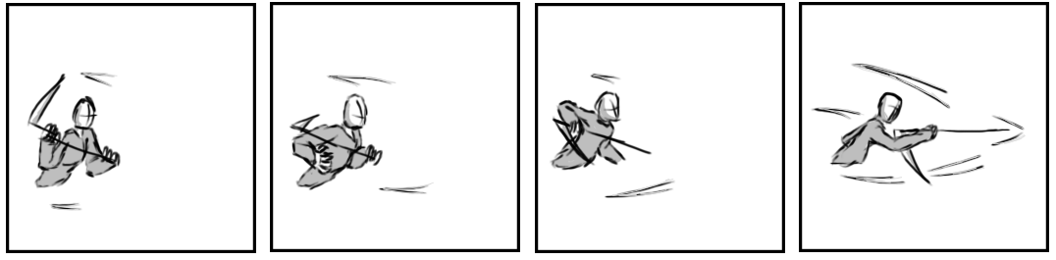**

Figure 3 - Animation Storyboard: Jab

**While grounded and stationary**: The player lunges forward with the scythe using it to stab the air in front of them. This will be a have the least exit lag out of all scythes attacks however will not apply life steal and will only attack either a minimal arc.

**Lesser Slash:  
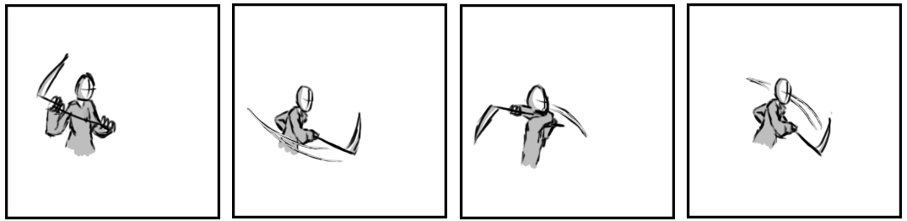**

Figure 4 - Animation Storyboard: Lesser Slash

**While grounded and in motion:** The player raises their scythe and swings it horizontally in front of them, after a moment of hit lag the player will swing the scythe again back to original side and again hold position due to its exit lag.

**Greater Slash:   
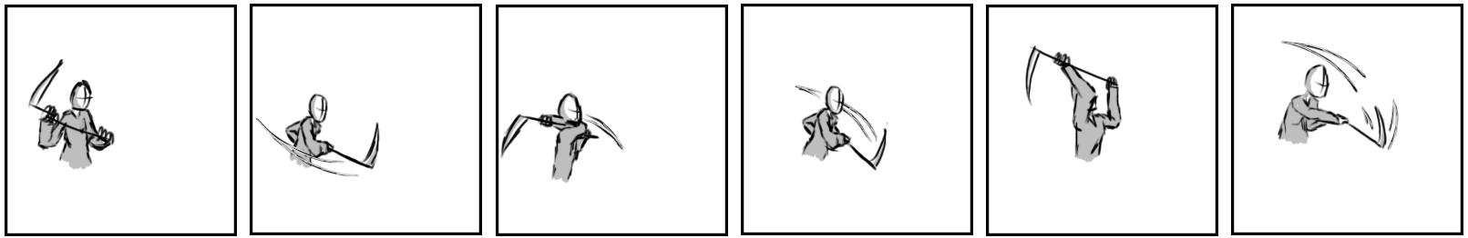**

Figure 5 - Animation Storyboard: Greater Slash

**While aerial:** Like the lesser slash. Each swing keeps the player airborne and will be angled towards the closest enemy within range, making sure it hits. The two swings of the lesser slash are followed up with a downward swing attacking vertically in front of the player.